HOLY WEEK SERVICES
St. Luke’s St. John’s
Sunday 24th March Palm Sunday 10.30 a.m. 10 a.m.
Thursday 28th March Maundy Service 7 p.m. 7 p.m.
Friday 29th March Good Friday 10 a.m. 2 p.m.
Saturday 30th March Easter Saturday 8 p.m.
Sunday 31st March Easter Sunday 10.30 a.m. 10 a.m.
St. Catherine’s services are at the normal times.
Sunday 24th March, Palm Sunday 9 a.m.
Thursday 28th March Maundy Service 9.30 a.m.
Sunday 31st March Easter Sunday 9 a.m.
***************************************************************

Those who have Died
New Brancepeth
Joan Adams, 19th February, aged 81 years
St. John’s, Brandon
Frederick Bellamy, 3rd February, aged 67 years
Elizabeth (Betty) Ayre, 8th February, aged 84 years
PARISH MAGAZINE - March 2013
St. John’s church, Brandon, St. Catherine’s church,
New Brancepeth, & St. Luke’s church, Ushaw Moor
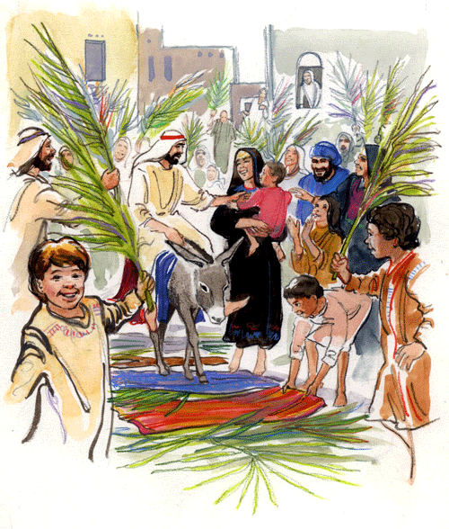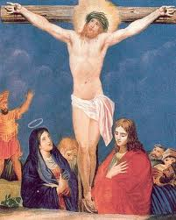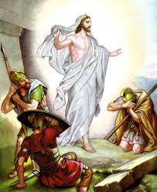
Sunday services
St. John’s - 10 a.m. Parish Mass followed by a cuppa
St. Catherine’s - 9 a.m. Parish Mass
St. Luke’s -10.30 a.m. Parish Mass
Weekday services
Wed. 9.30 a.m. St. John’s & St. Luke’s - World Peace
Thurs. 9.30 a.m. St. Catherine’s - New Brancepeth
A Parish Office is in the vestry at St. John’s on Mondays 6-7pm.
OR Tel: 0191 3780642 then leave a message & number.
Anyone requiring a priest in an emergency - Fr Keith Allison - 01207 529046
website http://www.brandonparish.org.uk/Welcome.htm
email - Webmaster@brandonparish.org.uk
ELECTORAL ROLL - Those wishing to be on the roll must complete an application form by mid-April. Forms are at the back of church.
St. Luke’s A.G.M. is on March 4th at 7pm followed by the P.C.C.
St. Luke’s Pie & Pea Lunch is to be held on Wednesday 6th March at 12 noon tickets £2.00 or pay at door.
St. Luke’s Easter Fair is on March 23rd in church hall at 10am.
St. Luke’s baptisms will be held after the Eucharist service on the first Sunday of the Month, at 11.45am.
St. Luke’s Church Hall
Monday at 7pm - SUMBA DANCING.
WALSINHAM PILGRIMAGE – this year will be the weekend of
June 14th led by Fr. Stewart Irwin. Please add your name to the list at the back of the Church.
Churches Together Lent Groups 2013
Brandon – weekly at St. Patrick’s Church House from Friday 15th February at 2.15pm. The York course booklet will be used. Queries to f.m.dobson@brancepethcastle.org.uk tel: 01913780628
Bearpark/New Brancepeth/Ushaw Moor – Thursdays from 2pm -3pm - Sharing our Faith, written by Rev. Rosemary Cox
March 7th – New Brancepeth Methodist church – Debs Brazier
March 14th – St. Catherine’s C.E. New Brancepeth- Liz GregorySmith
March 21st – Ushaw Moor Baptist church – Bill Guymer

New Brancepeth Messy Church
Messy Church is a joint venture by St. Catherine’s and New Brancepeth Methodist churches. It is held on the 2nd Wednesday of each month during term, 3.30 - 5.00 pm at New Brancepeth Primary School. About 20 children join in a series of craft and other activities based on a theme and the parents join us for some ‘worship’ for 15 minutes at the end.
The next one will be on Wednesday. 13th March, with the theme: ‘The Lord’s Prayer’.
In the Easter holidays there will be a special Messy Church for all families in the Village (no unaccompanied children) on the theme of ‘Easter’. This will be held at: 10.00 – 12.00 Thursday 4 April in the Village Hall (Pizza’s at 11.30). Please remember us in your prayers, and if you have children, come with them on 4 April!
Monday from 10 till 11am
in St. Luke’s Church Hall
Teenie Mix, Baby and Toddler Group.
Ages 18month to 4 years. Story, Craft,
cup-cake decorating & home-made snacks.
Pre-payment & booking essential £5.50 all-inclusive.
Contact Sarah: 07977 484767. sarah@minimixers.co.uk
FARM AFRICA
This is the story about the impact our support can make.
Four years ago, Dula Qale was struggling to feed his family in the Hamer area of Ethiopia. As a cattle farmer, he was forced to walk his cattle far from home in search of food during the dry seasons. While the cattle were away, his children were deprived of the milk that makes up most of their diet, leaving them at risk of illness and malnutrition for much of the year. That all changed when Farm Africa helped Dula Qale to buy a camel. Camels don’t need grasslands as they can survive on the leaves of trees that grow near the family home. Better still, they can provide three or four times as much nutritious milk as a cow. So, no matter how far away Dula Qale’s cattle are, his children now have plenty of milk to drink and are growing up stronger and healthier. We want to help many more families like Dula Qale’s to Give Hunger the Boot.
You could help someone like Dula Qale take great strides towards a better future. Help families like Dula’s to ‘Give Hunger the Boot’.
More info from http://www.farmafrica.org

St. John’s gave £89.60 to FarmAfrica in 2012 and St. Catherine’s have been supporting the charity since 1997.
In a letter from FarmAfrica – “Without churches like yours, FarmAfrica would not be able to reach people like Dula. By participating in the ‘Give Hunger the Boot’ campaign you are making a real difference to the farmers and families of Eastern Africa. Thank You.”
St. John’s PCC Report of 18th February 2013
At a meeting of St John’s PCC on February 18th 2013, the following proposal was accepted by the committee. ‘The PCC wishes to rescind the resolution A and B concerning women’s ministry in the Church of England.’ The vote was as follows:
For – 12 Against – 3 Abstention - 1
The PCC council will inform the Bishop of Jarrow of this decision.
Lesley presented the accounts for 2012 and gave an update on the amounts in the various accounts.
St John’s A.G.M. is on April 24th at 7pm in Church. The meeting will be addressed and chaired by Rev Robert Lawrence, Area Dean.

Contact Telephone Numbers
St. Lukes – Tom: 0191 3730845. Emily – 0191 3733780
St. John’s – Win – 3781156
St. Catherines – Liz – 3731554
Midweek services –
St. Luke’s 9.30 a.m. Wednesday Eucharist is followed by tea, coffee & biscuits.
St. Catherine’s 9.30 a.m. Thursday Holy Communion is also usually followed by tea, coffee & biscuits

The New Bishop of Durham
A public consultation meeting was held at Durham Johnston School (Sat. 16th Feb.) to help inform the process of selecting the next Bishop of Durham. It attracted more than 150 people and was attended by Caroline Boddington, the Archbishops’ appointments secretary, and Sir Paul Britton, the Prime Minister's appointments secretary. The appointment process was explained with two meetings of the Crown Nominations Committee (CNC) in May and again in June and it is hoped to announce the next Bishop during the summer.
Comments were made by a wide range of people at the meeting. Many said that the qualities seen in Bishop Justin were needed again, such as prayerfulness, leading from the front in mission and evangelism, ability to make a significant impact on the society in the North East and to inspire churches by his evident faith and confidence in God. He would need to reach out to the young in particular and develop the resources of the laity in making the gospel accessible in our area at this time. It was also said that he should not be thought of as a clone, but have the confidence to develop new initiatives within the Diocese.
More information is on the Diocesan Website:
http://www.durham.anglican.org/news-and-events/news.aspx
Prayer for the New Bishop
God of grace, we thank you for this Diocese of Durham, and for all your faithful servants whom you have called as bishops of this great See. Send your Holy Spirit to guide and direct all who have responsibilityfor the choice of a new bishop. Grant them godly discernment,unite them in a common vision,and keep us all faithful in prayer;through Jesus Christ our Lord. Amen
David Kennedy (2010)
A generous church
Bishop Mark welcomed people to the event and explained why we were holding a Diocesan Giving Day - to root Christian giving in prayer and discipleship. Canon Stephen Cherry said that the giving day was not another ‘Stewardship Sunday’ or ‘Gift Day’ but rather an opportunity to focus on the importance of giving in Christian faith and life without the pressure to give a particular call to action. Stewardship Development Officer, Alistair Jenkins spoke about some of the resources available to parishes to assist with the development of planned giving, and also highlighted the need to maintain momentum in this area throughout 2013, with events planned in May and September to ensure that the subject retains a high profile in parishes. Two sample sermons were preached at each of the sessions, with Bishop Mark being joined by Canon Bob Hopper (Vicar of Hillside) on Tuesday and the Revd. Sheilagh Williamson (Vicar of St. Columba, Darlington) on Saturday. All three sermons can be found on the website.
The report can be found online at - http://www.durham.anglican.org/news-and-events/news-article.aspx?id=387
Question to Ponder: What does community mean to you?
‘Every person has God given gifts. This means no community is so poor and helpless that it can’t improve its situation.’
Dominga B Anosan, Quezon City, Philippines.
(From Transition, the US Magazine)

