From the Registers
Those who have Died
St. John’s, Brandon
24th April Joyce Dawson
1st May Joyce Holmes aged 83 yrs
3rd May Raymond King aged 82 yrs
5th May Cynthia Henry aged 56 yrs
11th May Shirley Robey aged 73 yrs
*********************************************************

Contact Telephone Numbers
St. Luke’s – Tom: 0191 3730845. Emily – 0191 3733780
St. John’s – Win – 3781156
St. Catherine’s – Liz – 3731554
website http://www.brandonparish.org.uk/Welcome.htm
email - Webmaster@brandonparish.org.uk
PARISH MAGAZINE - JUNE 2013
St. John’s church, Brandon, St. Catherine’s church,
New Brancepeth, & St. Luke’s church, Ushaw Moor
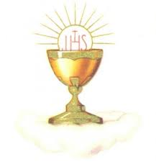
Sunday services
St. John’s - 10 am Holy Eucharist followed by a cuppa
St. Catherine’s - 9 am Holy Eucharist
6 pm – Evensong 2nd June
St. Luke’s -10.30 am Holy Eucharist
Weekday services
Wed. 9.30 a.m. St. John’s & St. Luke’s - World Peace
Thurs. 9.30 a.m. St. Catherine’s - New Brancepeth
Parish Office in the vestry at St. John’s - Mondays 6-7pm OR Tel: 0191 3780642 then leave a message and number
Anyone requiring a priest in an emergency :-
Capt. Ray Bradbury, Church Army – 01388 811430
St. Luke’s Summer Fair - will be on Saturday 15th June at 1.30pm. Donations for the bottle stall and fancy goods stall are welcome.
WALSINHAM PILGRIMAGE – this year will be the weekend of
June 14th led by Fr. Stewart Irwin. Please add your name to the list at the back of the Church.
St. Luke’s
Baptisms will be held after the Eucharist service on the first Sunday of the Month, at 11.45am.
St. Luke’s Church Hall
Mondays 10-11-MiniMixers. Monday at 7pm-Sumba Dancing
Held in the hand of God.
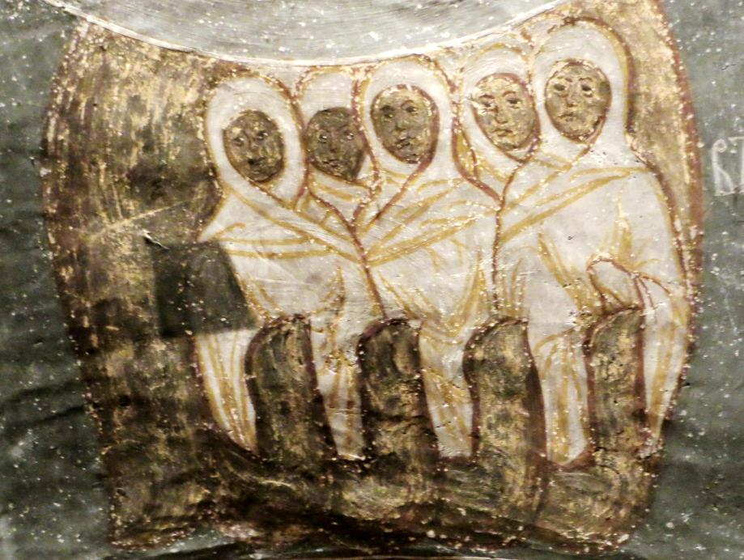
In North-East Romania there are a number of amazing painted monasteries (Orthodox) dating from the 16th century, decorated inside and out with brilliant frescos. At the one of them, Humorolui, on the underside of the archway into the inner nave there is this delicate picture of the hand of God holding the souls of men and women. We are safe in His hand (John 10:28)! Can you see God’s fingers holding the souls, dressed in funeral shrouds?
CORPUS CHRISTI
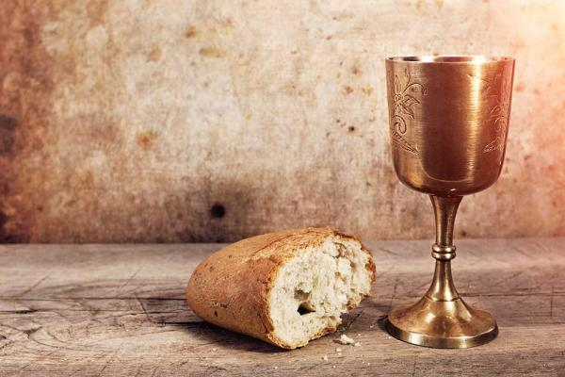
The festival of Corpus Christi celebrates the Eucharist as the body of Christ. The name 'Corpus Christi' is Latin for 'the body of Christ'.
In the Church of England this feast is also kept on the Thursday after Trinity Sunday and is known as the Day of Thanksgiving for the Institution of Holy Communion. Christians already mark the Last Supper, when Christ instituted the Eucharist, on Maundy Thursday. Because Maundy Thursday falls during the solemn period of Holy Week, it was thought necessary to have a separate festival of the Eucharist that would allow the celebration not to be muted by sadness. In 2013, Corpus Christi falls on 2nd June.
MOTHER'S UNION -
May 28th 2013 - Deanery Festival Service at 2pm in the Cathedral. A yearly service attended by all branches in the deanery with their Parish banners. A wonderful sight to see the Cathedral packed with MU members.
St John's Brandon branch meet in Church on the 2nd Monday of each month. If anyone would like to come along you would be very welcome.
The speaker on June 10th is Claire Wakefield, Deanery leader.

Record numbers of young Church of England ministers
New statistics for 2012 show that the number of young people (under 30s) accepted for training for the Church of England ministry last year was 113 – 22 per cent of the total. That is the highest number in 20 years and is the same as the statistics for the Diocese of Lichfield. Revd David Newsome, the Diocesan Director of Ordinand, said: “There is now a full recognition that ministers need to reflect diversity of Body of Christ – our church communities – with people of all ages. “Former Archbishop Rowan Williams said: ‘Without young clergy how can we speak the language of a new generation’.”

London pupils help build school for children in South Sudan
Children in South Sudan, whose school is currently a tin roof on poles will now be learning in purpose-built classrooms, thanks to the incredible efforts of their young counterparts at a primary school in London, in a special partnership fostered by CMS (Church Mission Society). Pupils at St Mary’s Church of England school in Finchley walked dogs, cleared leaves, and sold cakes amongst other things as part of the school’s 200th anniversary celebration appeal, which so far has raised more than £27,000 to build classrooms at Bilali Primary School in Eddi, Maridi diocese. Headteacher Rob Allen explains: “We wanted to echo what had happened at our school 200 years ago and give children in South Sudan access to education in what is one of the poorest countries in the world.” The vicar of St Paul’s, Finchley, the Rev Nicholas Pye, approached CMS about finding a partner school. Bilali Primary School was a fitting choice. “Bilali school was started under a mango tree by CMS missionaries in the 1940s teaching basic literacy to children,” said CMS transcultural manager for Africa Stephen Burgess. Between 2006 and 2009 the area was invaded by the Lord’s Resistance Army (LRA) from DR Congo and the villagers fled to Maridi, where they have been ever since as internally displaced people. “One thing that would help resettle people is if the primary school could be developed.”
Questions for Atheists – No. 3: Have you met Mother Theresa? (Adapted from a sermon by Revd. Lindsey Goodhew, 17/2/13)
This may appear a silly question, but the point is that the kind of religious people that some atheists appear to rail against bears no resemblance to many faithful believers through the ages. In a review of Dawkins book the God Delusion, Peter Williams, warden of the biblical research centre Tyndale House Cambridge, comments that card carrying rationalists like Dawkins invariably come up with ‘vulgar caricatures of religious faith that would make a first-year theology student wince.’ He goes on: ‘The God Delusion is liberally sprinkled with imaginary opponents as if Dawkins can’t be bothered to engage with the real opposition.’
Probably we never met Mother Theresa, but we may have met many faithful Christians living out their faith with humility, grace and compassion - men and women who embody Gospel living, revealing the very best of Christian faith.
Such lives present a living question to the Atheist.
In addition to this many atheists seem to deny a God that few of us would recognise – let alone believe in. Dawkins has described God as ‘a petty, unjust, unforgiving control freak; a vindictive, bloody ethnic cleanser; a misogynistic, homophobic, racist, infanticidal, genocidal, filicidal, pestilential, megalomaniacal, sadomasochistic, capricious malevolent bully. ‘
The Christ we meet in the Gospels and on the cross is not this God.
To dismiss God on the basis of such blatant misrepresentation of his character is shallow beyond belief. Alistair McGrath writes of Dawkins God: ‘Come to think of it, I don’t believe in a God like that either. In fact I don’t know anybody who does.’

"A towering spiritual figure": Archbishop meets Desmond Tutu
22nd May 2013
The South African archbishop and social rights activist "incarnates the grace of God," said Archbishop Justin. The Archbishop said the Church and the world owe “an enormous debt of gratitude” to Desmond Tutu when the pair met in London today. The Archbishop, who shared a private Eucharist with the Anglican bishop and Nobel Laureate this morning, said it was hard to imagine South Africa today without "the unrelenting presence and prayers of this towering spiritual figure".
The former Anglican Archbishop of Cape Town, who played a key role in fighting apartheid in South Africa, was in London to receive the Templeton Prize. “Like few others, Archbishop Tutu incarnates the grace of God – surviving decades of unthinkable trials and torment, he somehow did not forget how to dance or sing,” Archbishop Justin said.
“More recently his name has become synonymous with the courage to face truth and the pursuit of reconciliation. I thank God for this life of inspiration and witness.”
Archbishop Tutu received the Templeton Prize for his lifelong work in advancing Christian principles of love and forgiveness - extended across political boundaries - which have helped liberate people around the world.
At the award ceremony in London last night, Archbishop Tutu spoke of how people were created for "togetherness".
“Ubuntu – a person can be a person only through other persons," he said. "You can be generous only because you learnt from another how to be generous. How God longs for us to know that – you know what – we were created for togetherness. We were created to be members of one family, God’s family, the human family."
The South African leader joins a distinguished group of 42 former Templeton recipients including last year’s Laureate, the Tibetan Buddhist spiritual leader, the Dalai Lama. It celebrates living persons who have made an exceptional contribution to affirming life’s spiritual dimension, whether through insight, discovery, or practical works.

Archbishop Justin on settling into life in Kent - Sunday 19th May Writing in Kent on Sunday newspaper, Archbishop Justin looks forward to spending time with his family in the Diocese of Canterbury and
"worshiping God alongside everyone else"

The last year has been full of surprises – a new job of course being one of them. But within those surprises have been many blessings, including now having a home in Canterbury where we can spend part of our time. A base in Kent is hugely important to us. It’s a place where we can come and be refreshed and renewed. Getting settled hasn’t been all plain sailing; we are still trying to figure out which is the best takeaway in Canterbury – and still getting lost most times we step out of our front door. But we feel deeply privileged to call this place home. We can see now why it’s called the Garden of England. We keep nudging each other, slightly in awe, and saying: “This place is amazing. It’s so beautiful.” From Romney Marsh to Dover, from the Medway Towns to the North Downs, there is so much to visit, and so many people to meet – the daunting thing is whether we will manage to do it all. In addition, the Diocese of Canterbury, which is the oldest in the Church of England, is extremely important to me as an archbishop. As the months and years unfold, I’m looking forward to working with the Bishop of Dover to support the priests throughout the diocese, helping them to grow the communities in their churches. This means doing the simple things: taking services, meeting people, listening to stories, sharing the Gospel, inviting people to discover the love of Jesus Christ for themselves – and worshiping God alongside everyone else. Put simply, the people and churches of Canterbury will help me to stay in step with the normal rhythm of Christian life. Next month I’ll be taking the services at Canterbury Cathedral where new deacons and priests will be ordained. Commissioning new ministry in the church will be a humbling reminder that men and women continue to devote themselves to living out their love of God. I hope to meet some of you there, or elsewhere in Kent over the exciting and challenging years to come.

