From the Registers
Wedding at St. Johns
26th May Thomas Stephen Curry & Emily Rosebud Dodd

Funeral at St. John’s
26th June John Cook

Funerals at St. Catherine’s Church
24th Reg Parker
7th Billy Newman

Funerals at Crematorium
22nd May Valerie Mary Wood
30th May John Bregazzi
22nd June Geoffrey Burns

Events
PMC Congregational Event, Sunday 16th July, St. John’s at 10.45 after the Eucharist. This is an important event reviewing the activities of the 9 months and looking forward to what we might do in the future. Refreshments provided. Please come if at all possible.
Future Date: Please put in your diary
PCC Day Away: Saturday 16th Sept. This open meeting will review the past year and decide on one or two specific ‘experiments’ for the year ahead.

DH7 Churches Together Quiet Day: Saturday 5th August at Minstreacres. This is an annual event with reflections led by one of the community amid the wonderful setting of the Minstreacres Retreat Centre. Queries contact Bill Offler, williamoffler@outlook.com or David/Liz Gregory-Smith. Lifts can be arranged.
(This months’ magazine is rather brief, due to time pressure! – sorry)
Brandon Parish Magazine
July/August 2023
St. John’s Church, Brandon &
St. Catherine’s Church, New Brancepeth
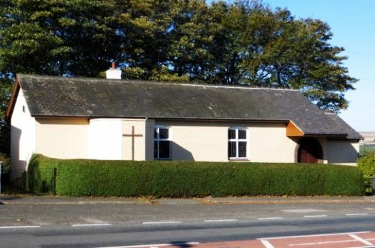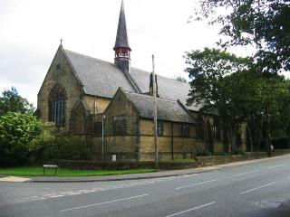

Regular Services:
St. John’s: Holy Eucharist on Sundays – 9.45 am,
Mondays – 7.00 pm
Wednesdays – 9.00 am
St. Catherine’s: Holy Eucharist on Sundays – 8.45 am,
Thursdays – 9.30 am
Morning Prayer Thursdays – 8.45 am
Tuesdays and Fridays: Fr. Carl leads Morning Prayer on zoom at 8.30. Contact Fr. Carl for an invitation.
Contacts
Fr. Carl Peters: The Clergy House, Sawmill Lane, Brandon,
Durham, DH7 8NS. Tel: 0191 6803875, revpeters28@gmail.com
Other Contact Telephone Numbers
St. John’s: Carolyn – 6803875
St. Catherine’s: Joe – 3739927; Liz – 3731554
Website http://www.brandonparish.org.uk/Welcome.htm
https://www.facebook.com/StJohnTheEvangelistChurchBrandon
https://www.facebook.com/Stjohnschurchhallmeadowfield
https://www.facebook.com/pg/StCatherinesChurchNewBrancepeth
For our priest letter we have Fr. Carl’s sermon on Trinity 3 based on Romans 6:1b–11
Sometimes we hear people say something like: ‘You can’t go back, you can only go forward.’ Or: ‘There’s no going back.’
Often people are referring to a certain place or situation in life. Perhaps we liked living somewhere once in a former life, but it would be the wrong thing to go back and live there now. Maybe there was once a favourite holiday destination where we went when the family was young, but now the children have grown up and moved out going back wouldn’t be the same.
Or perhaps we went through a trying situation and it was very uncomfortable at the time. There might be regret attached to it and we might want to go back in time and prevent the situation happening. But we can’t, there’s no going back!
Such resignation to what’s happened in the past, doesn’t have to be covered in gloom, because we can turn it into something positive and concede that we’ve learned from our situation and the only way now is to go forward.
All this really brings us to Christian life and what Paul is talking about in his letter to the Romans today.
Once we become a Christian, if we’re going to take it seriously, there’s no going back. Something has changed for us and we can’t be exactly the same person we were before we were baptized for instance, whether baptism came in infancy, childhood or adulthood.
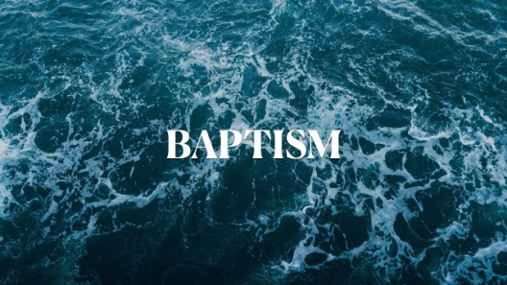
And that’s because if we realize the enormity of our baptism, then we will see that the imprint of Christ is on us. And that God imprint makes a difference in our lives. It means that we can’t be as we might want to be in our weaker moments, of which there are many in life. But rather, we must be as God wants us to be.
The waters of baptism and belief of that act means that we live our lives in Jesus as he lives his life in us. Indeed we share in the drama of Jesus death and risen life.
Paul makes clear to the Romans that there is no going back once we believe in Jesus when he says at the beginning of our reading.
‘Should we continue in sin in order that grace may abound?’
In other words, if we have our faith, does it matter if we sin as well? We believe in God don’t we?
To which Paul answers,
‘By no means! How can we who died to sin go on living in it?’
Christians have nothing more to do with sin, Paul is saying. We’ve moved on. Of course, we’re not perfect and it’s a struggle, but Christ comes to our aid to help us. Jesus is by our side. In fact Paul is saying, ‘it isn’t us that live anymore, but Christ who lives in us.’
When we were baptized, we were baptized into Jesus’ death. In effect as we descend symbolically into the waters of baptism, we are buried with Christ in his death. In doing so we drown the old life we had, so that we can share in the life of the resurrected Jesus, by coming out of the waters again, washed and clean and starting a new life.
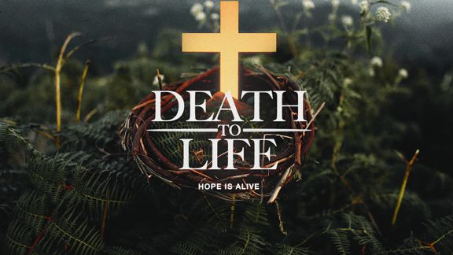
As new Christians we go from death to life. And we go on to live in the shadow of the Cross as a reminder that our sin dies on the Cross with Jesus. We can’t go back, we can only go forward. Of course life is life and we do slip up. It’s not as cut and dried as all that. But if we realize that we’ve gone wrong, we look at Christ’s imprint on us and as we stand in the shadow of the Cross, we place our sins on the Cross. And that’s where they stay. That’s where they’re dealt with. So that we can move on and not look back.
And that’s good news for all of us. We don’t have to be chained down with guilt and be captive to our sins. Yes, we might want to go back and change things, because that’s human nature. But in Jesus we don’t have to go back.
His death wipes our slate clean. And his life becomes our life. And forward we must go. Amen

