From the Registers

Funerals at St. John’s Church
8 July David Anthony Wilson
Funeral at St Catherine’s
12 July George David Mountain
Funeral at Crematorium
9 August June Fenwick
16 August John Robinson

Services and Events
COMBINED AND OPEN PCC Meeting, Wednesday 7th Sept. 6.30 pm, St. John’s Church: This is a meeting of the PCC’s from all of Fr. Carl’s churches, St. John’s, St. Catherine’s, St. Luke’s and St. Paul’s. The main topic is to hear from Fr. Kyle McNeil about an initiative called ‘Partnership in Mission Church’ (see article in the magazine). Anyone from all the congregations is encouraged to come as we consider the way forward for our churches. Please come if you can!
Songs of Praise and Harvest Festival at St. Catherine’s: Sunday 18th Sept. at 4.00 pm. Contact Liz if you would like to suggest a hymn.
Mothers’ Union, Wednesday, 14th September, 2.00 pm at St. John’s.
DH7 Churches Together Climate Sunday Service Sunday 4th September at 6:00pm, St Michael’s Catholic Church Esh Laude, DH7 9QN. Queries, contact williamoffler@outlook.com and 0191 3782883
Brandon Parish Magazine
September/October 2022
St. John’s Church, Brandon &
St. Catherine’s Church, New Brancepeth
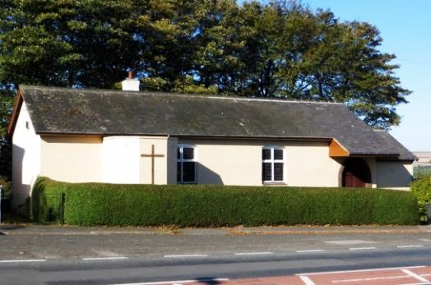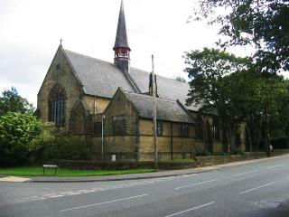

Regular Services:
St. John’s: Holy Eucharist on Sundays – 9.45 am,
Wednesdays – 9.00 am
St. Catherine’s: Holy Eucharist on Sundays – 8.45 am,
Thursdays – 9.30
Morning Prayer Thursdays – 8.45 am
Tuesdays and Fridays: Fr. Carl leads Morning Prayer on zoom at 8.45. Contact Fr. Carl for an invitation.
Contacts
Fr. Carl Peters: The Clergy House, Sawmill Lane, Brandon,
Durham, DH7 8NS. Tel: 0191 6803875, revpeters28@gmail.com
Other Contact Telephone Numbers
St. John’s: Carolyn – 6803875
St. Catherine’s: Joe – 3739927; Liz – 3731554
Website http://www.brandonparish.org.uk/Welcome.htm
https://www.facebook.com/StJohnTheEvangelistChurchBrandon
https://www.facebook.com/Stjohnschurchhallmeadowfield
https://www.facebook.com/pg/StCatherinesChurchNewBrancepeth
PARTNERSHIP FOR MISSIONAL CHURCH (PMC)
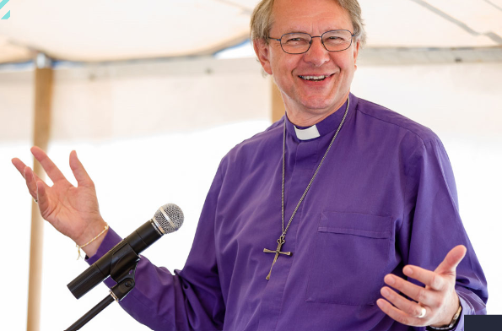
“It’s a wonderful journey that helps churches discover a sense of purpose, discern the call of God, and engage in joyful, hopeful mission in their local communities.”
Rt Rev Paul Butler, Bishop of Durham
We’ve all recently lived through so much change in so little time. The question is, will we lean into this change and join in with what God is doing in our communities? Or will we avoid it, and miss the chance to be part of something greater?
The PMC journey invites churches to take a look at ourselves, our communities and our calling, and to step out in deep, radical faith to discover what God is up to around us and how we can be part of it.
Churches navigating change. Together.
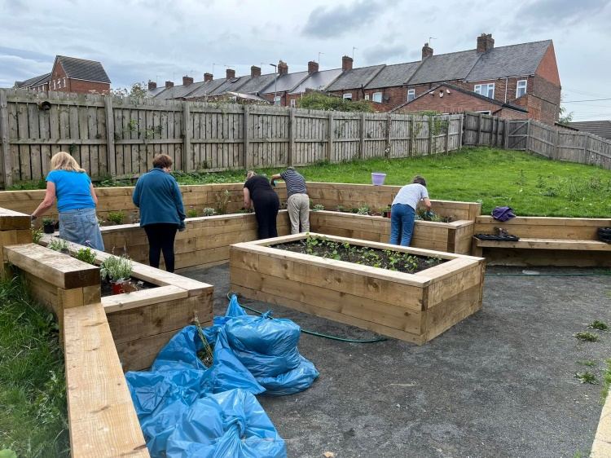
Each church that joins in PMC forms part of a cluster of 10-15 churches who share the journey, learning together in community while applying the underlying PMC principles to their unique context. Churches of all kinds are encouraged to join: big, small, urban, rural – and all denominations are welcome. Because PMC does not offer a cookie-cutter approach, every congregation’s story will be unique.
Empowering every member
PMC is serious about setting all God’s people free into God’s mission – not just clergy. Each participating PMC church sends a mix of clergy and lay people in teams to join the process, which is guided by PMC facilitators trained by CMS (Church Mission Society).
A unique process
Real change and true growth take time. The full PMC process is a three-year journey, but churches are welcome to sign up for just the first year initially to test the waters.
Photo Lesley Baxter
The funding for the summer activities in the Hall was sponsored by the Fun and Food and the mid-Durham AAP.
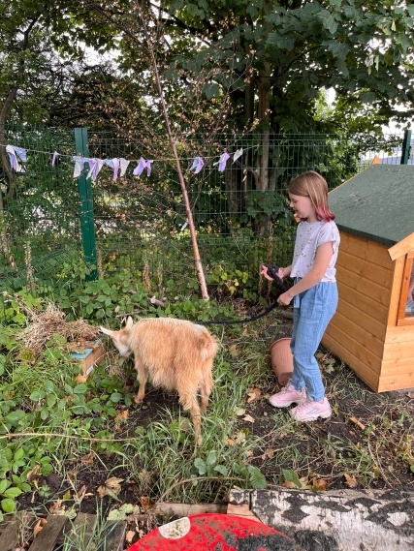
Some illustrations of the activities:
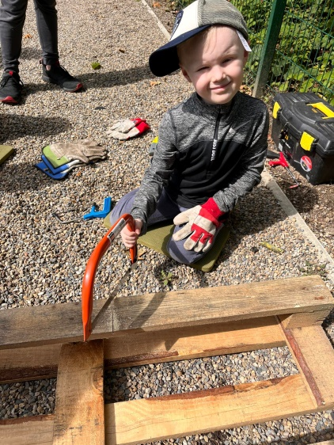
Hudson 6 said “my favourite animals was the Guinea pigs, they were really cute and also small”
I love the swing in Mummy’s Forest school.
Lydia walking a baby goat round the garden. Photo Lesley Baxter

Photo Nikki Kell

St John’s Hall received over £14,000 from believe housing ltd for the next stage of the garden work. Volunteers can contact Lesley Baxter 0784 6542035.
Volunteers putting in the first plants into the new planters to start the sensory garden: plants with touch, smell, sight and to attract wildlife.
St. John’s Hall News and Activities
Mon. St Johns Church Play group 9.30 am. (term time only)
Pilates with Paul 12.15 pm -1.15 pm. £5 07804 541181
Tues. Hartbeeps 10 am Happy House, 11 am baby beeps, 12.15 pm
Baby Bells. 1,15 happy House Contact Abby 07534 018440
7pm-8pm intermediate Ballroom, Latin and sequence dancing with Dianne Ross 0776 9632412.
Wed. 9.30 am Paul’s over 50’s circuits. 07804 541181 (can just turn up).
SOSA dance fitness classes 10.45 to 11.45 am. Trudy 0778 7419022
Elvet Quilters 2pm to 4pm Contact Eileen 0782 8395718.
Pilates with Paul 5.30pm – 6.30 pm . 07804 541181 £5.00.
Line dancing fitness with Vicky 0798 4009418
Thurs. Swing-Fit dance 10 am . £6.00 Contact Joo-Lee 0771 9174544.
7pm-8pm Beginners Ballroom, Latin and sequence dancing with Dianne Ross 0776 9632412
8pm-9pm improvers Ballroom, Latin and sequence dancing with Dianne Ross 0776 9632412.
Fri. 9.30 am baby movers, 10.30 am Little movers contact Sarah 07738 375126 or durhamandseaham@littlemovers.net
The guiding groups can be contacted through www.girlguiding.org.uk
Sun. Yoga 11.30 am to 12.30am Contract Dimitra 07773643369
Saturday July 30th over 50 children enjoyed a visit from animals about town . They met a chicken, rabbits, goats and sheep. They learn about the animals and could hold the smaller ones and walk the goats round the garden who enjoyed the apples from the fruit trees. The visit was followed by healthy wraps and the children made animals from fruit. All funded by DCC fun and food scheme for the summer holidays, aimed at providing activities and healthy food.
The animals visited again on August 30th.
Mon. Aug. 1st saw the first of four summer forest schools funded by DCC fun and food, 25 children enjoyed joining in with outdoor activities followed by fish fingers , baked beans and sweet corn and fruit.
More events are planned for October and Christmas half term. See Facebook page stjohnshallmeadowfield for details.
Year one focuses on listening, paying attention and discovering where God is already at work. It’s about discerning God’s unique gifting and call for your church in its community.
Year two moves into experimenting. Based on what churches discover about themselves and their communities in phase one, the next step is to experiment and learn from what works well and what doesn’t. This is all done with people in the local community, not just ‘for’ them.
Year three is about creating a realistic and sustainable vision for the church that can be lived out by everyone in the congregation.
Stories:
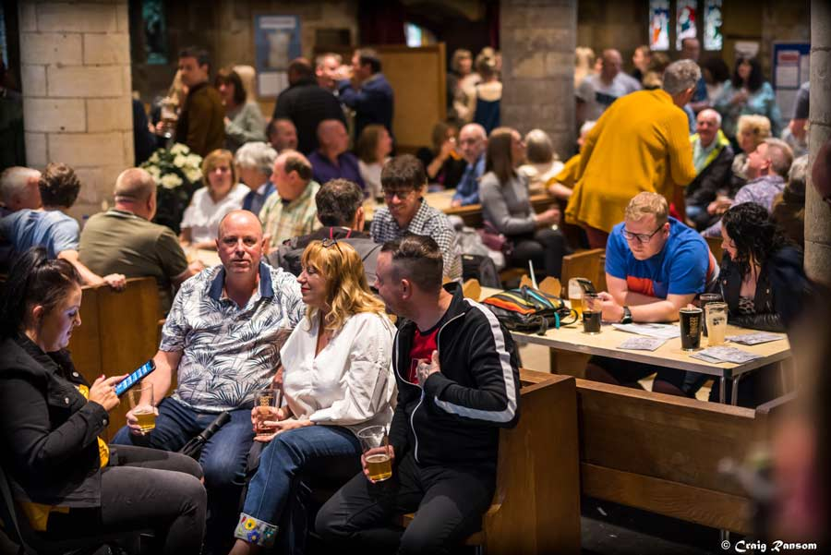
A church in Durham diocese welcomed 1,200 people from the local community to an unusual event over four days in June 2019 – a beer festival in partnership with local businesses.
Members of St Mary’s Norton welcomed those attending and spent hours in conversation with parishioners who had not been to the church for decades. So what changed?
St Mary’s was one of a group of churches in Durham diocese to embark upon a new journey with the PMC process. This is journey of listening to both God and the local community, experimenting and taking risks in mission, then discerning how God is calling the church forward in his mission in the community.
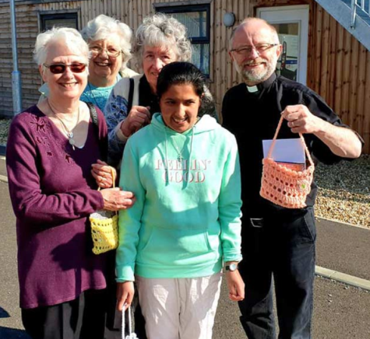
On Holy Saturday, the small congregation of Caversham Park Church, based on a large housing development on the edge of Reading, were taking part in a prayer walk around their community and distributing Easter gifts.
Church member Christine Viney says their church is now more a like a river – flowing out into the community. “I enjoyed doing the questionnaire [an early part of the PMC process] – talking to people and getting a bit under the skin of what was happening in the village. People said there was no centre – they were feeling lonely.”
In response, the members of Caversham Park started a coffee morning based at a local social club and a monthly bring-a-friend lunch at a local cafe. Along with the Easter (and Christmas) prayer walks, these are a sign of confidence, wanting to be visible Christians in the community, says the vicar, Derek Chandler.
PMC has also, says Derek, had for the congregation “a profound effect in terms of discipleship and God being a real presence that’s around every day of the week, not just someone you visit on Sunday.”
“We have some tealights in the form of a cross at the front of the church,” explains Christine, “and people come and say how they’ve seen God working during the week and just light a candle in thanks and praise to God. That’s what’s helped me personally, the way of seeing God in everything.”
Information from: https://churchmissionsociety.org/partnership-for-missional-church/
Please come, if you can, to the meeting on Wed. 7th July at 6.30 pm in St. John’s
Fr. Carl’s sermon for Trinity 9, 14th August seems relevant – the Christian life involves challenges! (Readings, Hebrews 11:29-12:2; Luke 12:49-56)
Sometimes in our lives we know that the path ahead is going to be particularly difficult. Things we have to face. Things we have to do. Endurances we’d rather not endure. Without doubt the present Ukrainian refugees would rather not have endured what they’ve had to go through in order to get to a safer place. Better still, they’d rather it hadn’t all happened in the first place! In their Exodus from slavery in Egypt, I’m sure the people of Israel weren’t relishing the crossing of the Red Sea and the living in the wilderness. Indeed we hear in the Exodus how they complained about what they had to endure, even though God was with them. And later in the story, I would think Joshua and his men would be looking forward to better more peaceful times as they faced the enemy and surrounded the walls of Jericho, before the walls came tumbling down! And it must have took some endurance as Rahab the prostitute went through the anxiety of being found out, when she sheltered the Israelite spies, who were planning to overthrow her very people.
And when we read on in our Epistle to the Hebrews, we hear how the faithful of Israel had endured hardship and persecution during what the author of the letter is referring to, which was the Maccabean Revolt. Unpleasant times indeed! As a people suffered punishment and destitute ‘wandered in the deserts and mountains, and in caves and holes in the ground.’
We might not quite compare ourselves to the circumstances mentioned, but we do sometimes have to go through the bad in order to get to something better, if we do indeed get safely to the other side.
One comfort for Christians is, we have someone to look to, who was not exempt from the endurance of hardship. Indeed he is the ultimate example of one enduring hardship for the sake of the joy to come! And that is Jesus.
Jesus had a job to do in obedience to his Father. And it was a challenging and uncomfortable mission he was on. Jesus says in Luke’s Gospel today.
‘I came to bring fire to the earth, and how I wish it were already kindled! I have a baptism with which to be baptized, and what stress I am under until it is completed!’
Stress indeed as Jesus speaks to the people, the message that ‘fire’ purification, is necessary for them and this will mean for them testing and judgment. Endurance for Jesus and endurance for his people. As Jesus embarks on his Exodus on that final journey to Jerusalem, people become divided as Jesus faces his opposition. The journey is far from calm. It is a sea of troubles where currents drag people down and split them apart! But ultimately Jesus is the one who calms the sea, as he accepts the cup and endures the Cross of pain that brings about the establishment of God’s Kingdom.
May we too, disregard the shame of the cross, embrace it, carry it, bear the weight of it, and follow Jesus into that kingdom. It might be tempting to give up. To turn back like the Israelites wanted to do in the wilderness, but the more we get a glimpse of the kingdom as our eyes open, the lighter our burden will be. Amen

